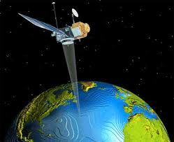
Benha University
Faculty of Engineering _Shoubra
Surveying Engineering Department
Fourth Year
Year: 2017/2018
Semester: One
Remote Sensing and Photo Interpretation
Assignment No: 6

Multispectral, Thermal, and Hyperspectral Sensing
- What is meant by Multispectral Scanner?
- Write short notes about the Hyperspectral sensors.
- Define the following terms:
- Thermal Capacity.
- Thermal crossovers points.
- Charge coupled devices (CCD).
- FLIR Systems.
- Geostationary Orbit.
- Sun Synchronous Orbit.
- Discuss the geometric characteristics of Across-Track scanner imagery.
- State the different methods used to calibrate thermal scanners and discuss one of these method.
- What are the important characteristics of a satellite remote sensing system? Discuss these characteristics in case of LandSat 1, 2, and 3.
- Write in detail about the following:
- Across-Track Scanning.
- Along-Track Scanning.

